

ASSIGNMENT – 02

COURSE : AWS DEVOPS

Trainer : Mr . MADHUKAR REDDY

NAME: B.Sravani

Mail-id:sravanireddybhavanam1@gmail.com

* **CREATE THREE INSTANCES, INSTALL NGINX AND APPLY APPLICATION LOAD BALANCER (ALB):**

Create a security group.

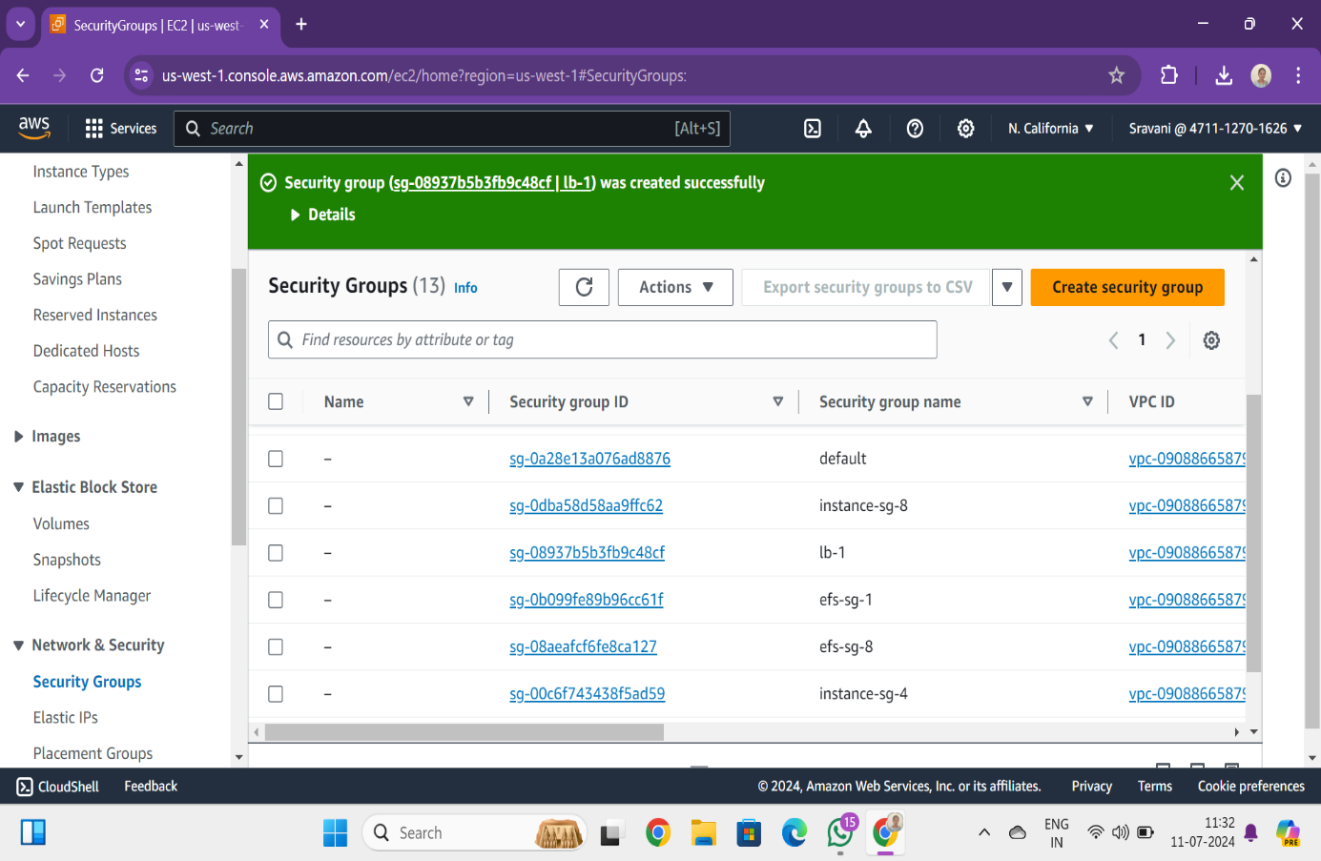

Create a instance.

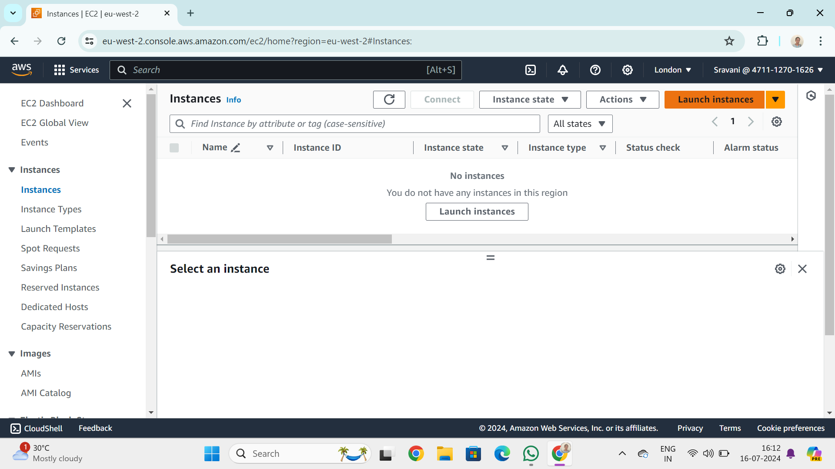

Repeat the same process two times to have three instances.

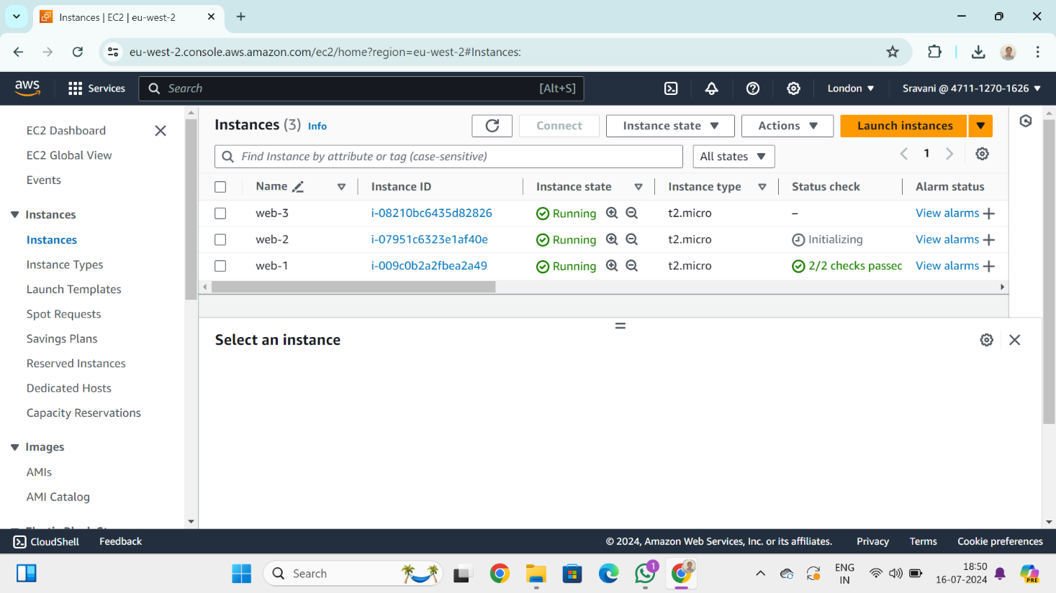

Connect to instance and copy the command from SSH client to check the instance if it is working or not on OS.

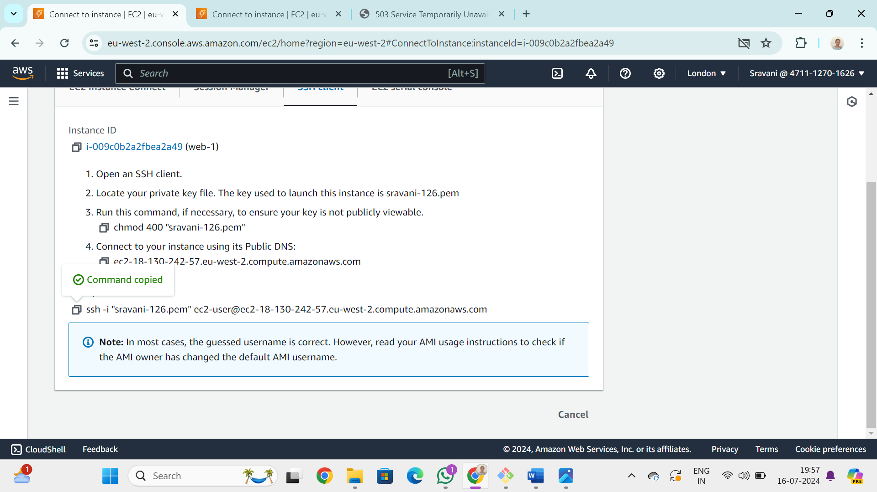

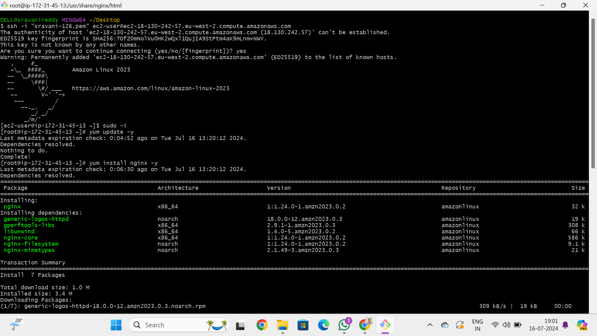

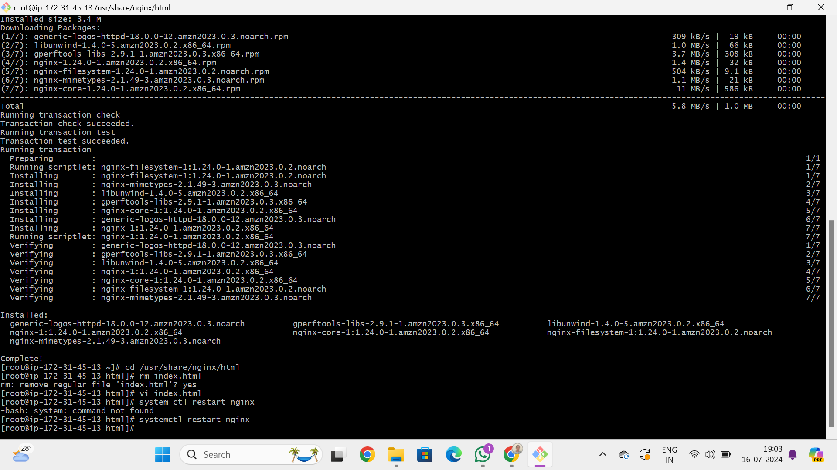

Copy IP address form EC2 instance.

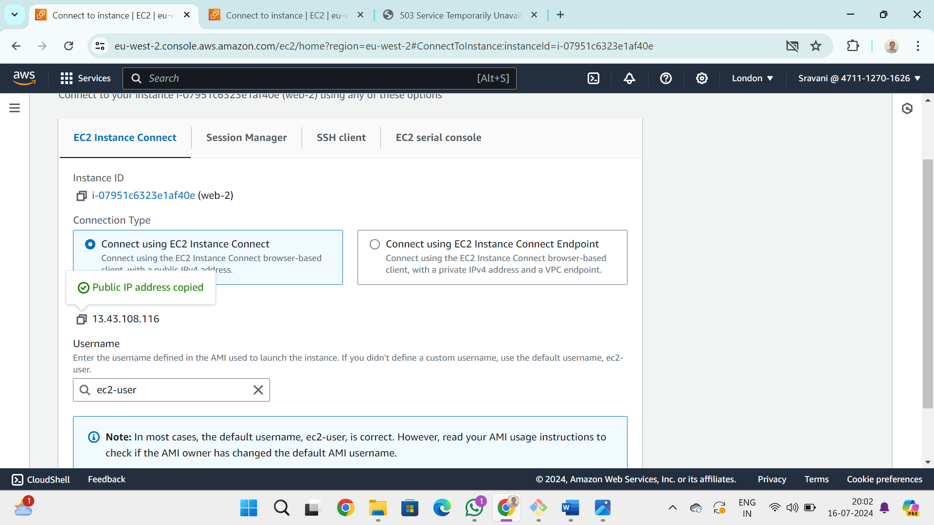

Paste it on web browser to check the data in instance.

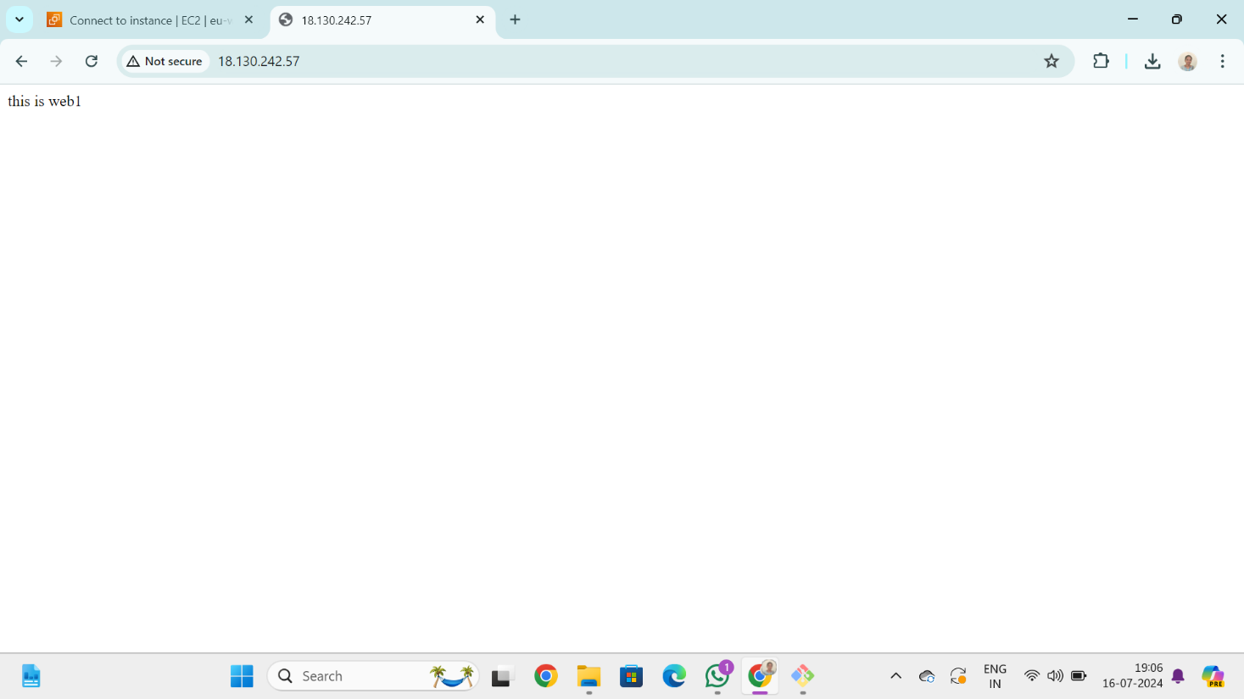

* Repeat the same process with other two instances.

Create target group.

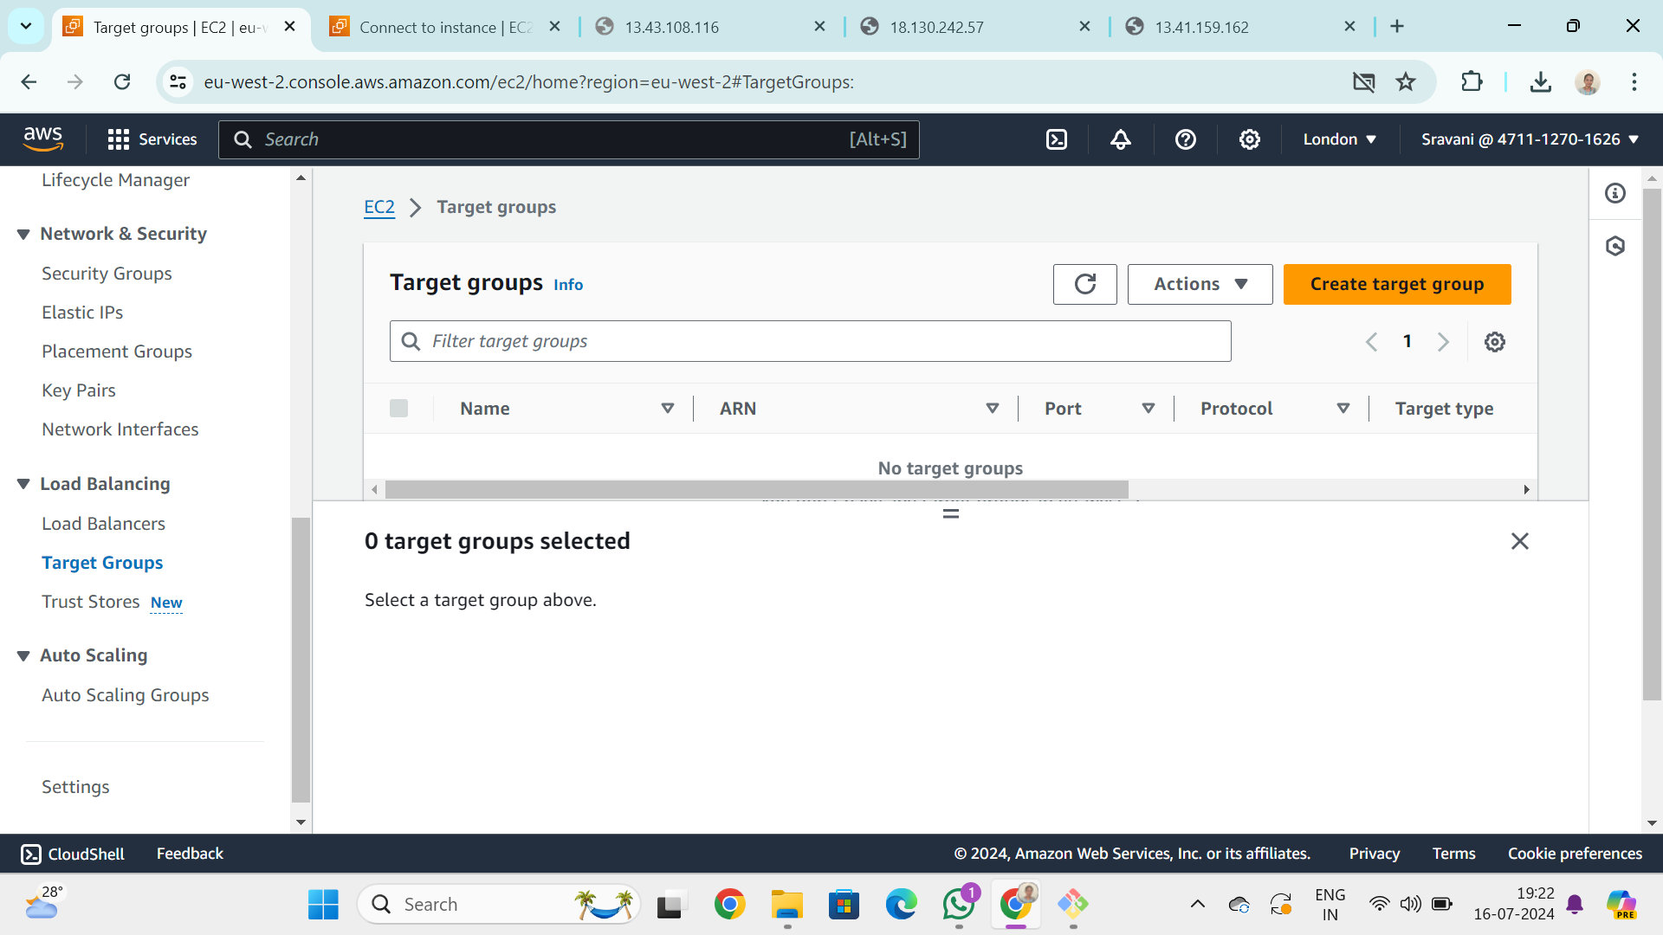

Register three instances in targets.

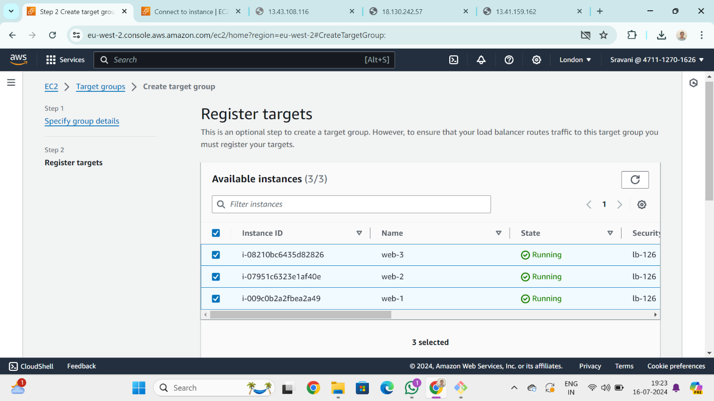

Click on create target group.

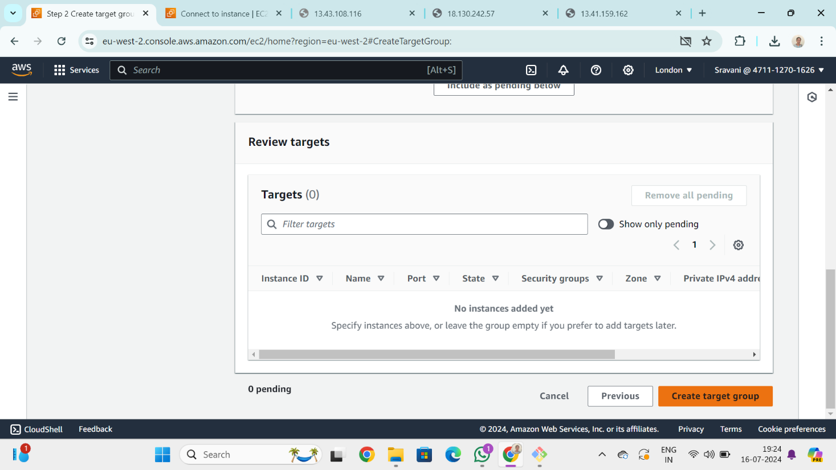

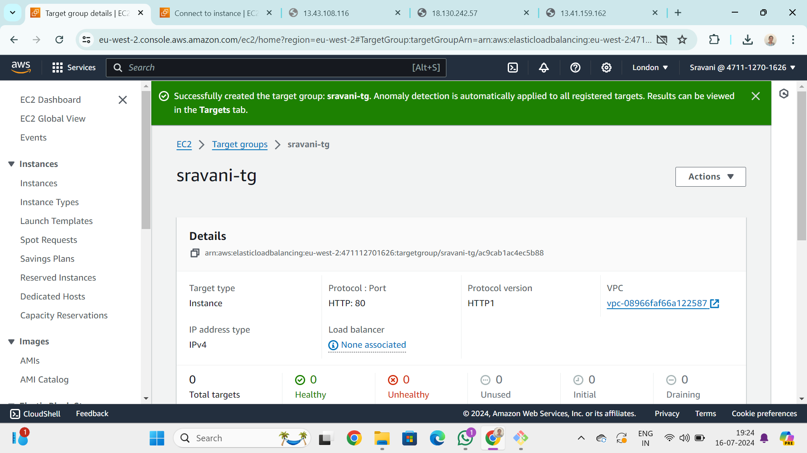

Create a load balancer.

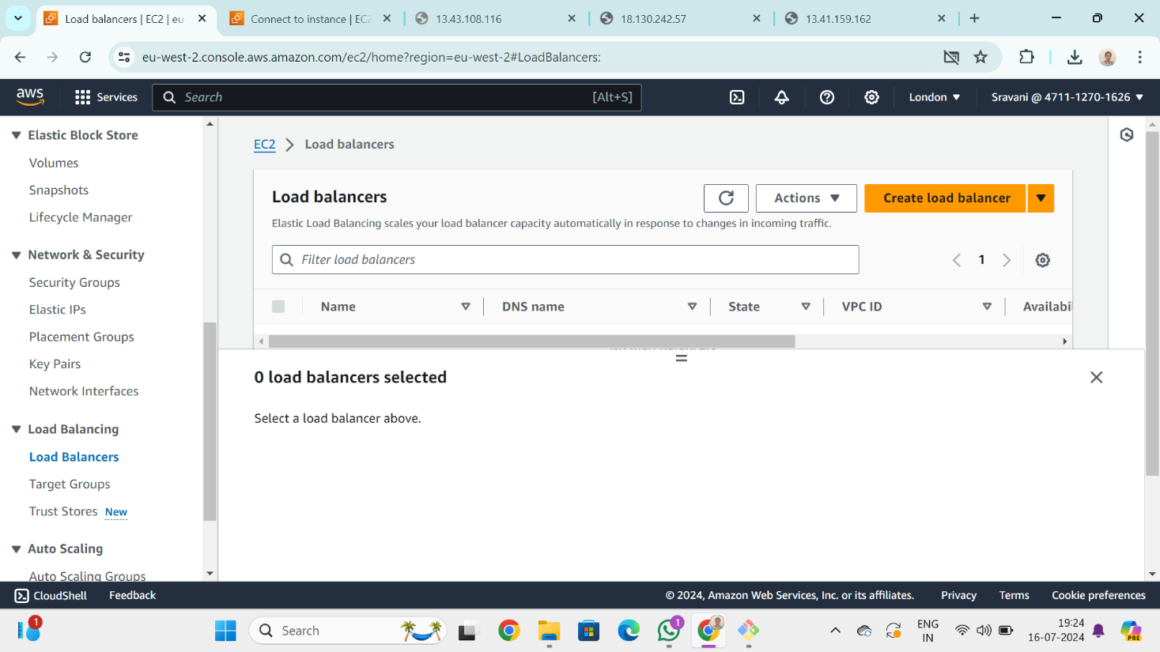

Copy the DNS name from load balancer.

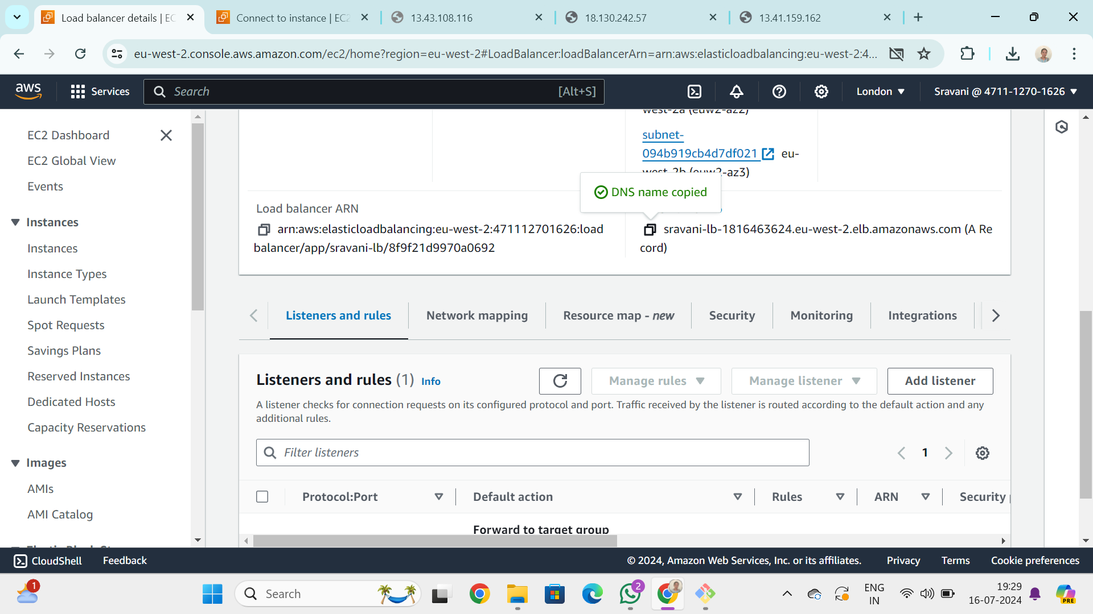

Check the copied link in web browser and do refresh and it shows the result be like-

First refresh.



Second refresh.

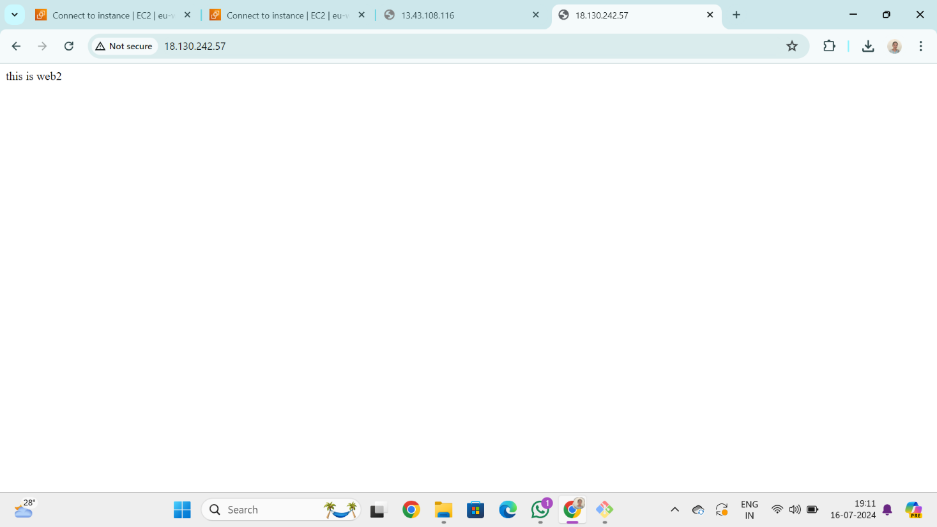

Third refresh:

